Android project – student hub

WEB & MOBILE PROGRAMMING (CSE5590) PROJECT - 2

Submitted by: TEAM 11

**STUDENT HUB – TABLE OF CONTENTS**

1. Introduction 1
2. Work flow 2
3. Code screenshots x
4. Output screenshots x
5. Contributions x
6. Challenges x
7. Conclusion x
8. References x
9. **Introduction:**
   1. **Motivation and significance**

A mobile application software or mobile app is an application software designed to run on mobile devices such as smartphones and tablet computers. Most such devices are sold with several apps bundled as pre-installed software, such as a web browser, email client, calendar, mapping program, and an app for buying music or other media or more apps. Some pre-installed apps can be removed by an ordinary uninstall process, thus leaving more storage space for desired ones. Where the software does not allow this, some devices can be rooted to eliminate the undesired apps.

So here we tried to develop an application which gives particular information to students depending on the username like their class schedule, current news and today’s weather report where API is used, we can also store the student’s schedule frequently and update the schedule.

* 1. **Objective:**

Our objective is to provide a user friendly app to the students to check their attendance and class schedule frequently and this also helps students to gain some knowledge about what’s going around with world with the updated news.

* 1. **About the Project**

Our project is a mobile application which allows the students users to search and get their class schedules, Our project focuses on letting the students know about the updated class schedule and reported weather forecast and updated news.

Basically when we have to store details of particular person we write all the details on some paper and also if we have to attend particular event on some day we forget until someone remains about the event so we usually end up delaying it or not going to attend. For that we come with idea to store all the personal details of the person and also store the events like basic schedule you are going to do in the coming hours. Additionally this apps helps the students to stay updated with the general news and information about weather is also included.

* 1. **Features:**

The homepage UI is created in xml and this allows users (via the Sign activityto sign up using their username and password which is then stored in a database SQLite .The user may use the clickable functions to get the information about updated news and weather forecast. After logging in user can see their profile information (can be updated), schedule (can be updated), weather, and news in a easy view, tabbed layout. There are many advantages with the use of this application. Store personal details with username and password known, to remind about the schedule.

1. **Work Flow:**

We designed in such way that initially the user has to register with app and then he is automatically redirected to fill some personal details of the user and we can now login after filling all the personal details.

After completing the first step the user now have to undergo login process if the login is successful then the page is redirected to display page of the user initially it shows all the personal details of the user. After login is successful we are initially taken to personal details of the user and then we have tabs and view pager so that we slide them to see the schedule , weather and News. If any schedule is not present then we are going to add the schedules by clicking on floating action button then we are going add the schedule where the app displays the time and all the courses Types. We can logout from the present account directly from the home tab.

The other two click buttons would be associated with the API’s where a student can actually click on the weather forecast button to check updated weather information and the other API is used to get top 10 news that are usually for students from around the world.

1. **Code Snippet:**

Add To Login Table:

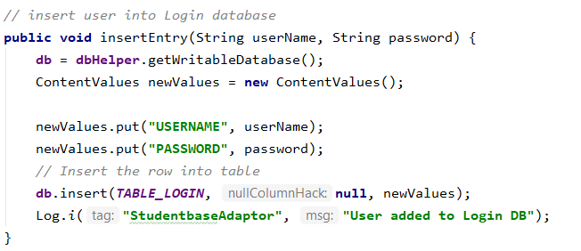

Capturing Profile Image:

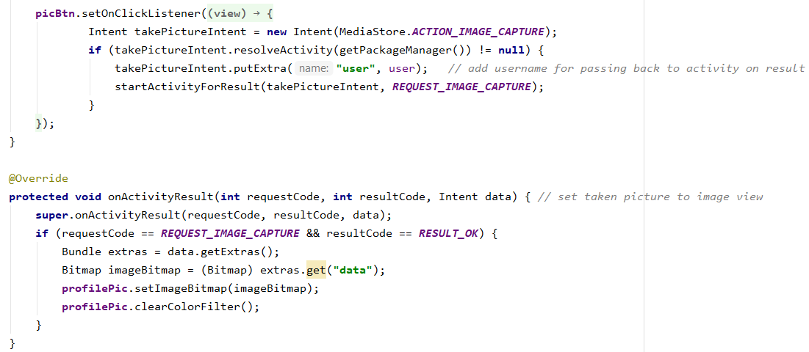

DB Image to UI:

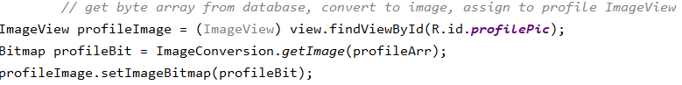

Image Conversion Class:

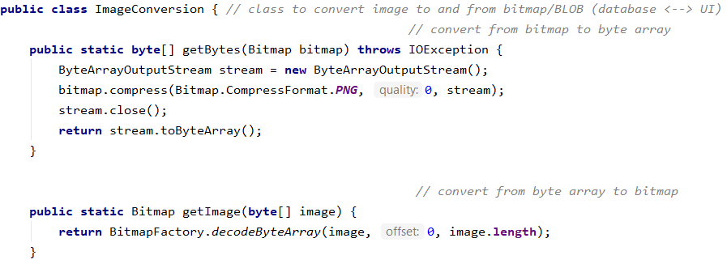

Login Validation:

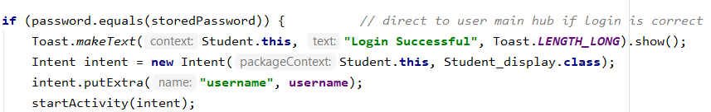

Retrieve from details & schedule:

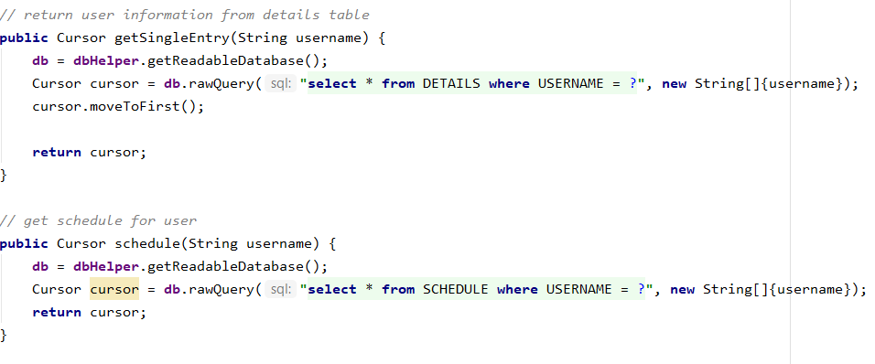

RSS Feed API:

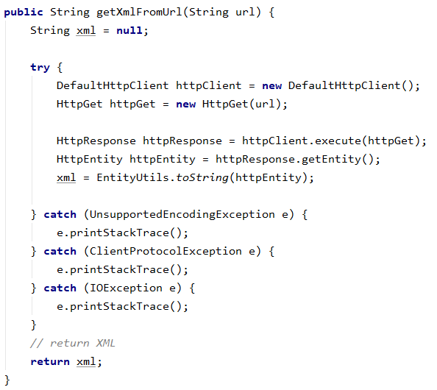

Schedule Alert:

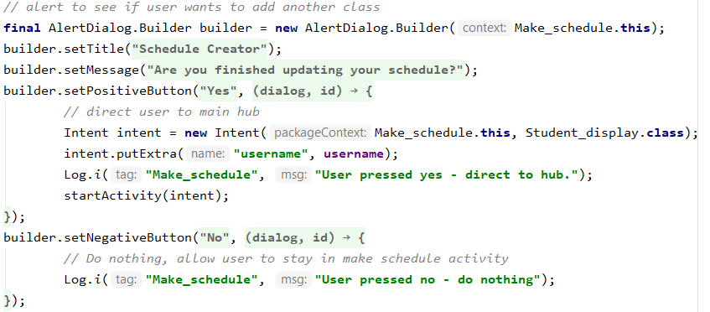

Schedule View:

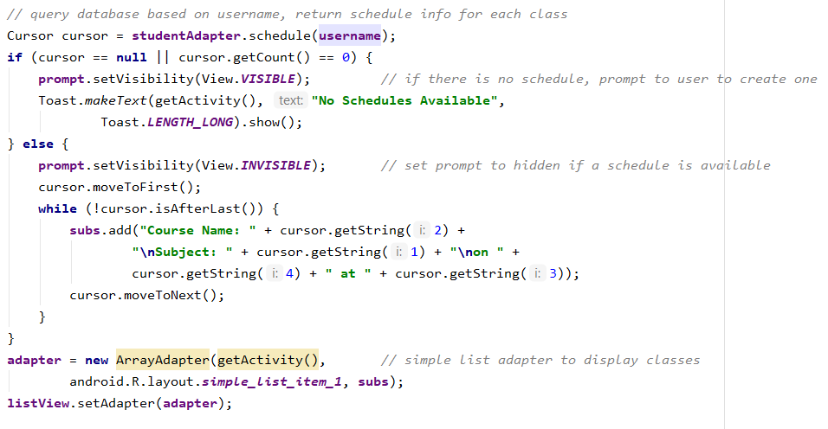

Set Weather ICON:

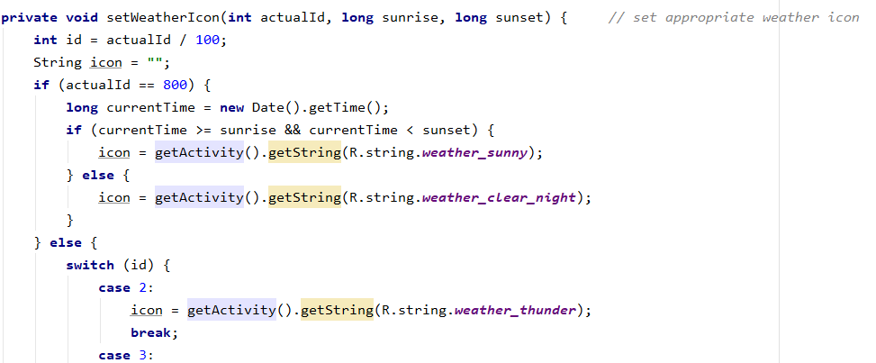

Sign UP Validation:

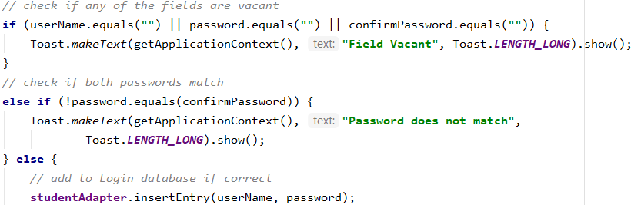

Strings to User Details:

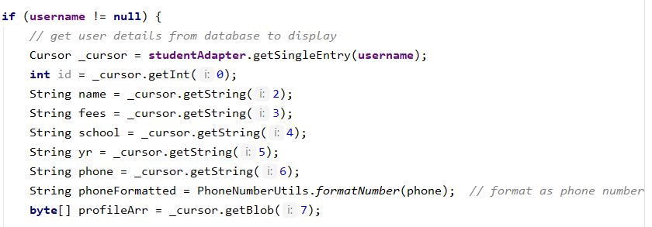

Tab Layout:

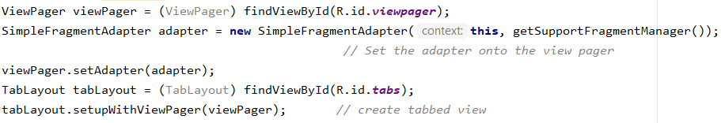

Weather API Call:

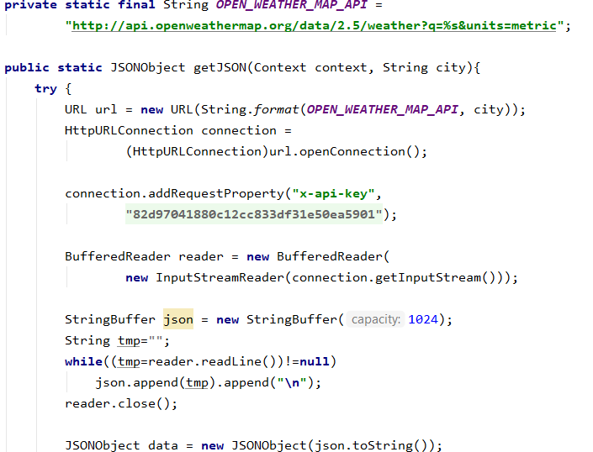

Web Browser Setup:

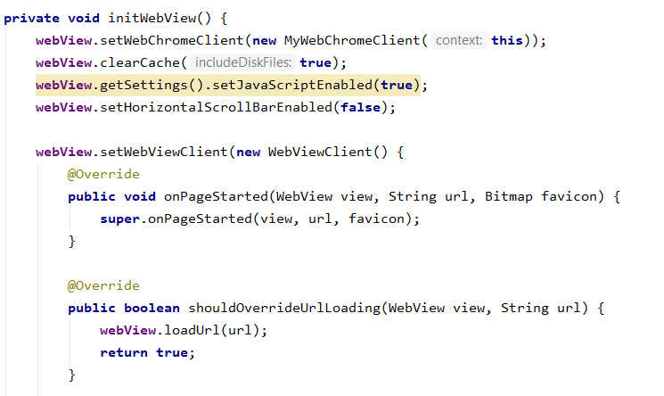

1. **Screenshots:**

Add Schedule:

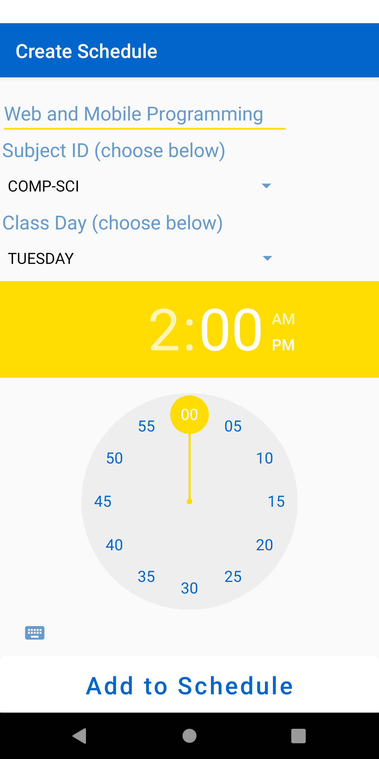

Create Profile:

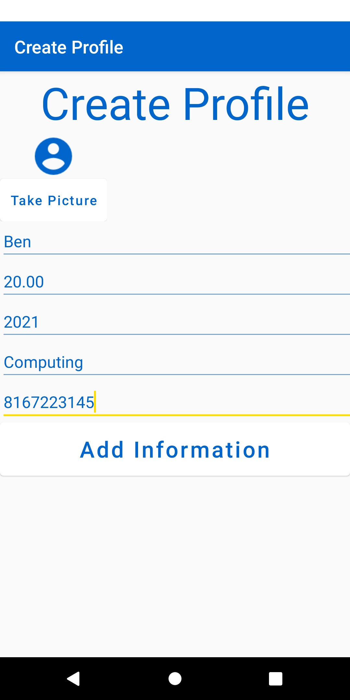

Home:

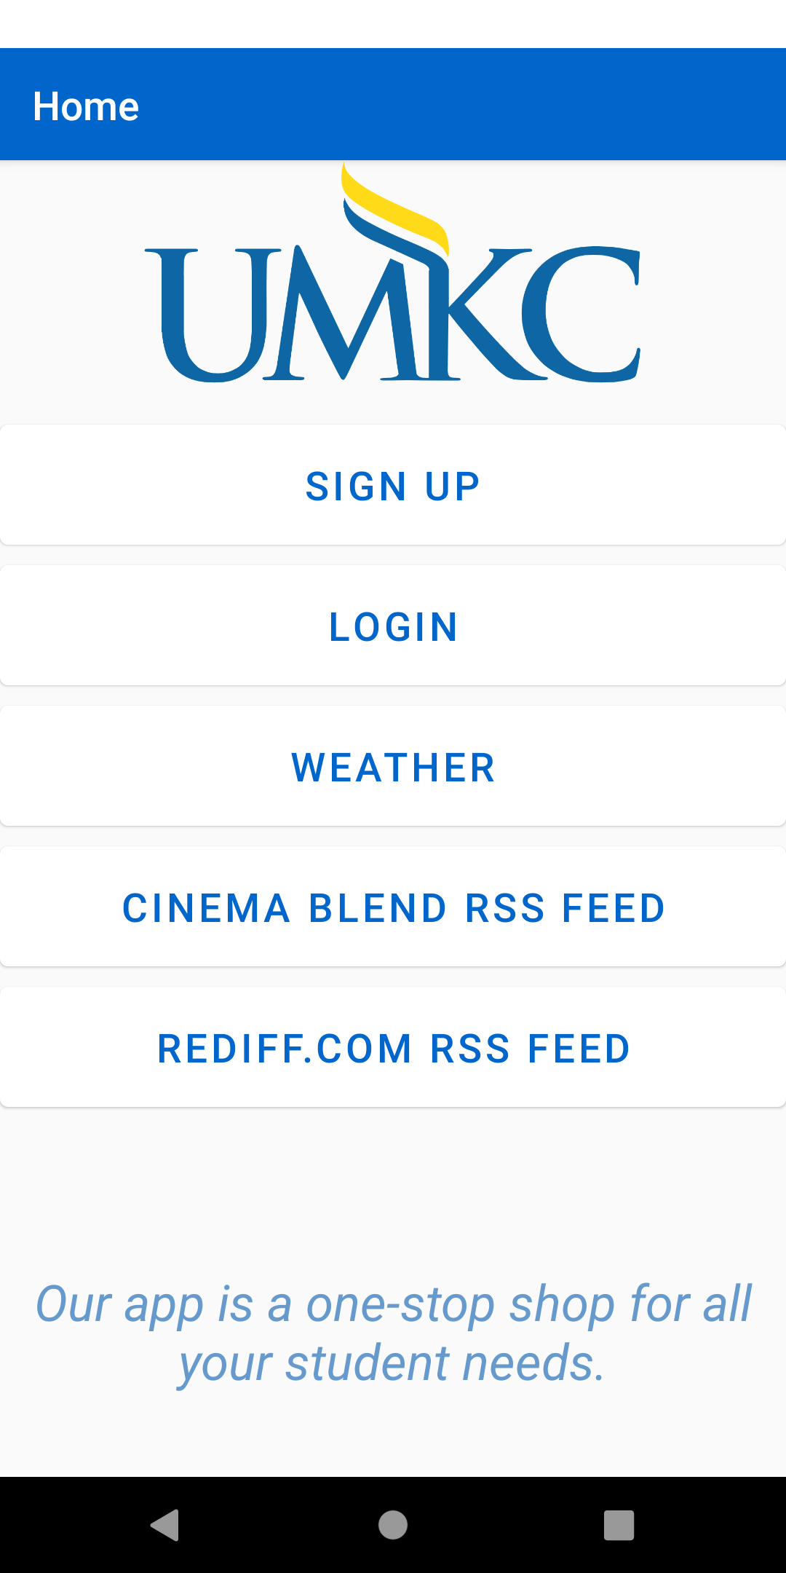

Icon:

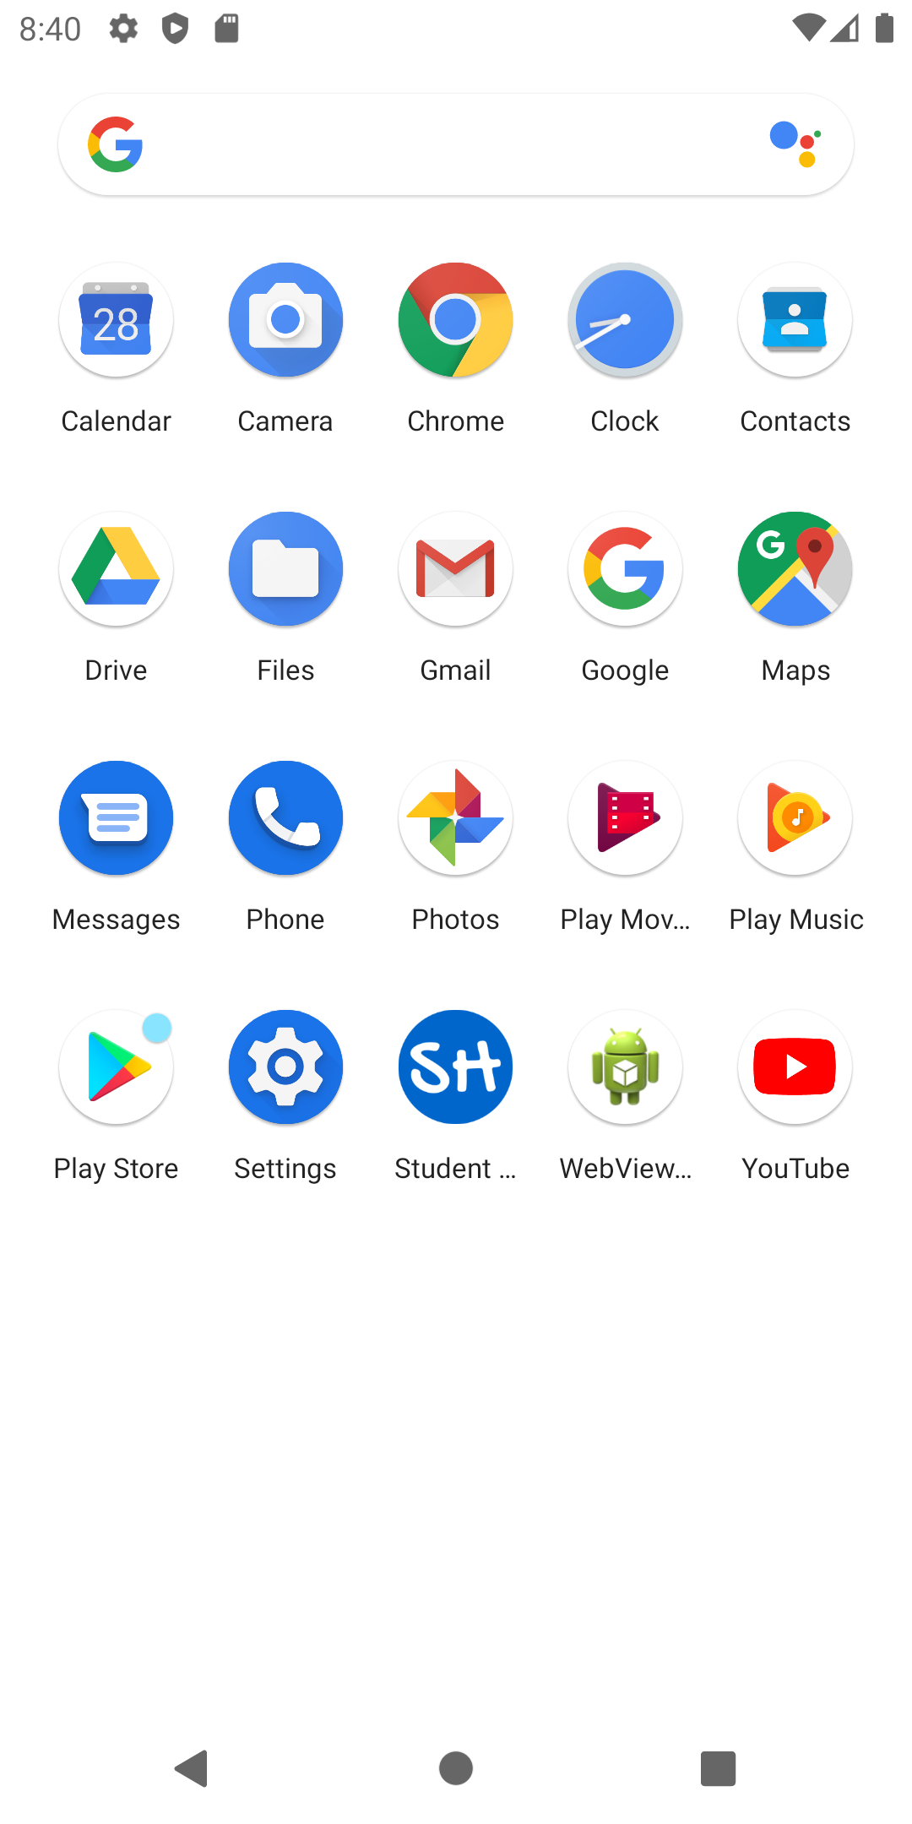

Login:

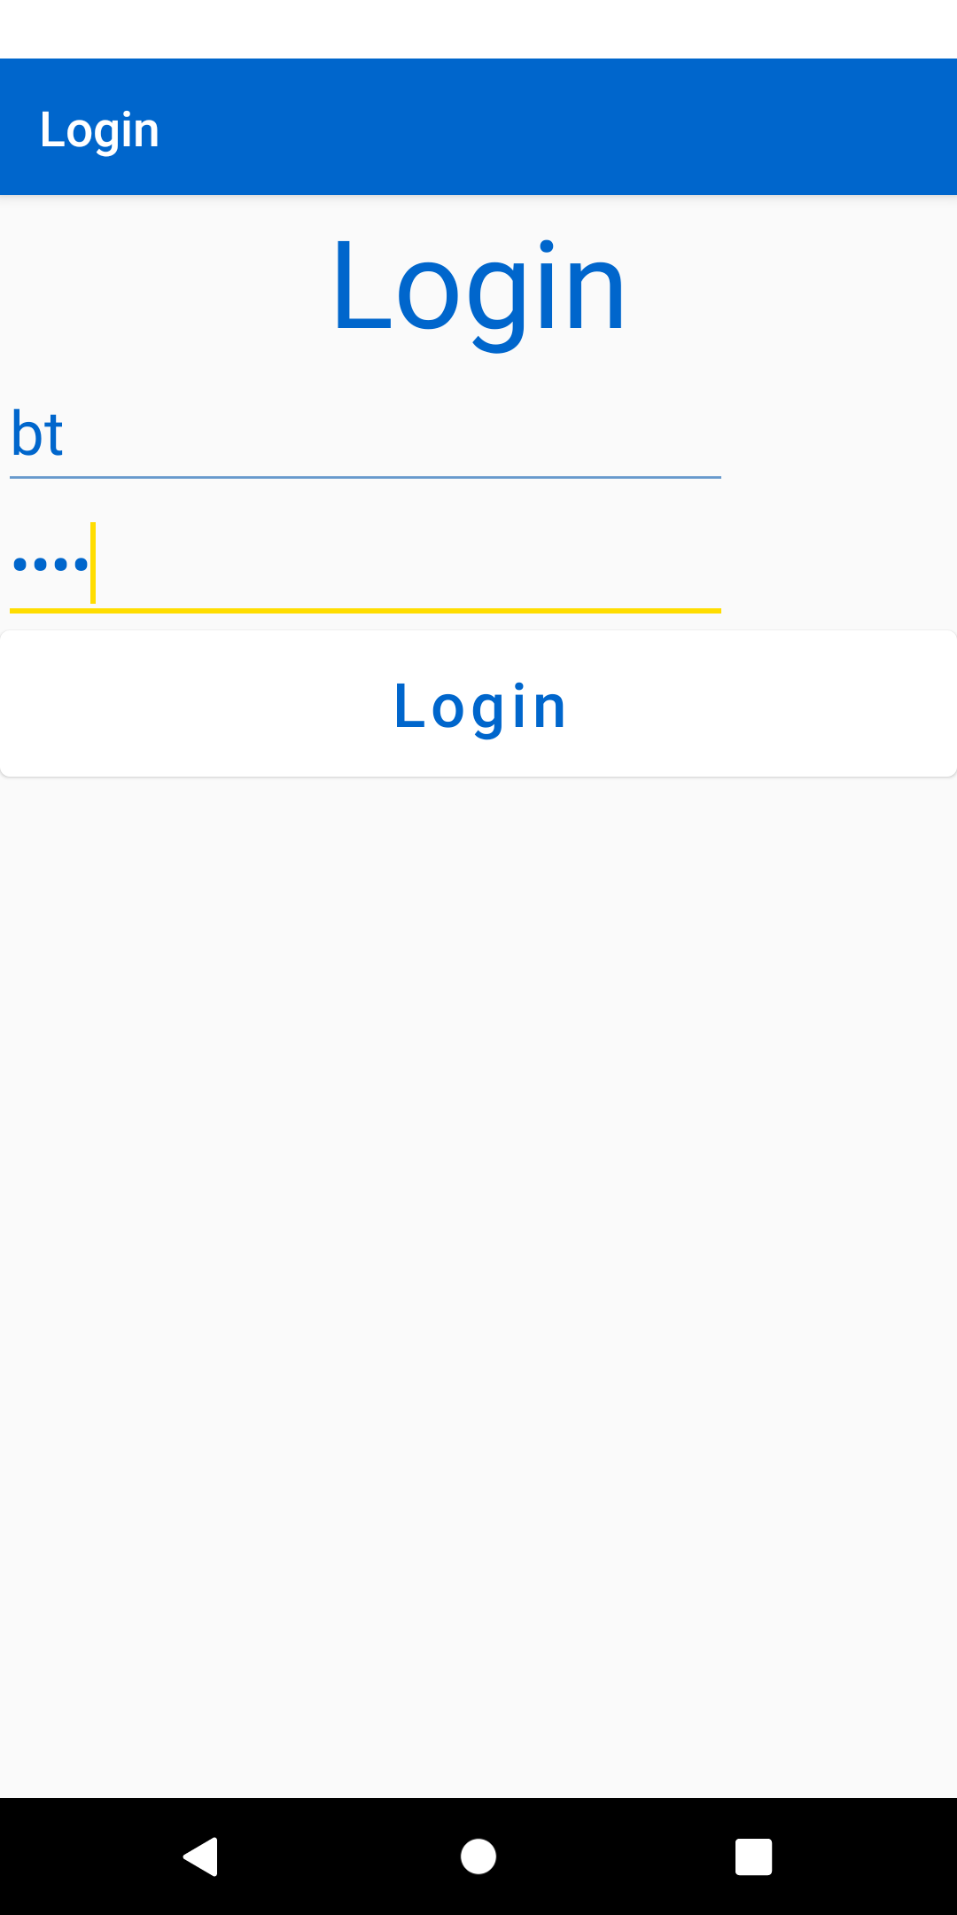

RSS Feed:

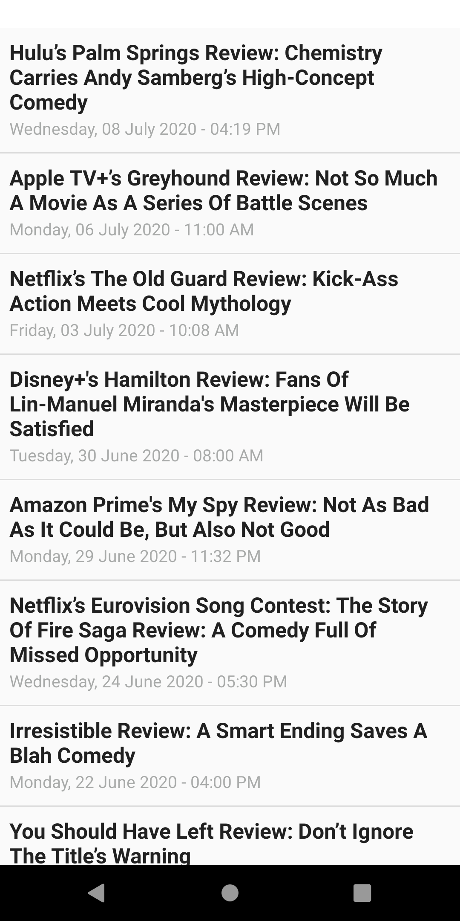

Schedule Dialog:

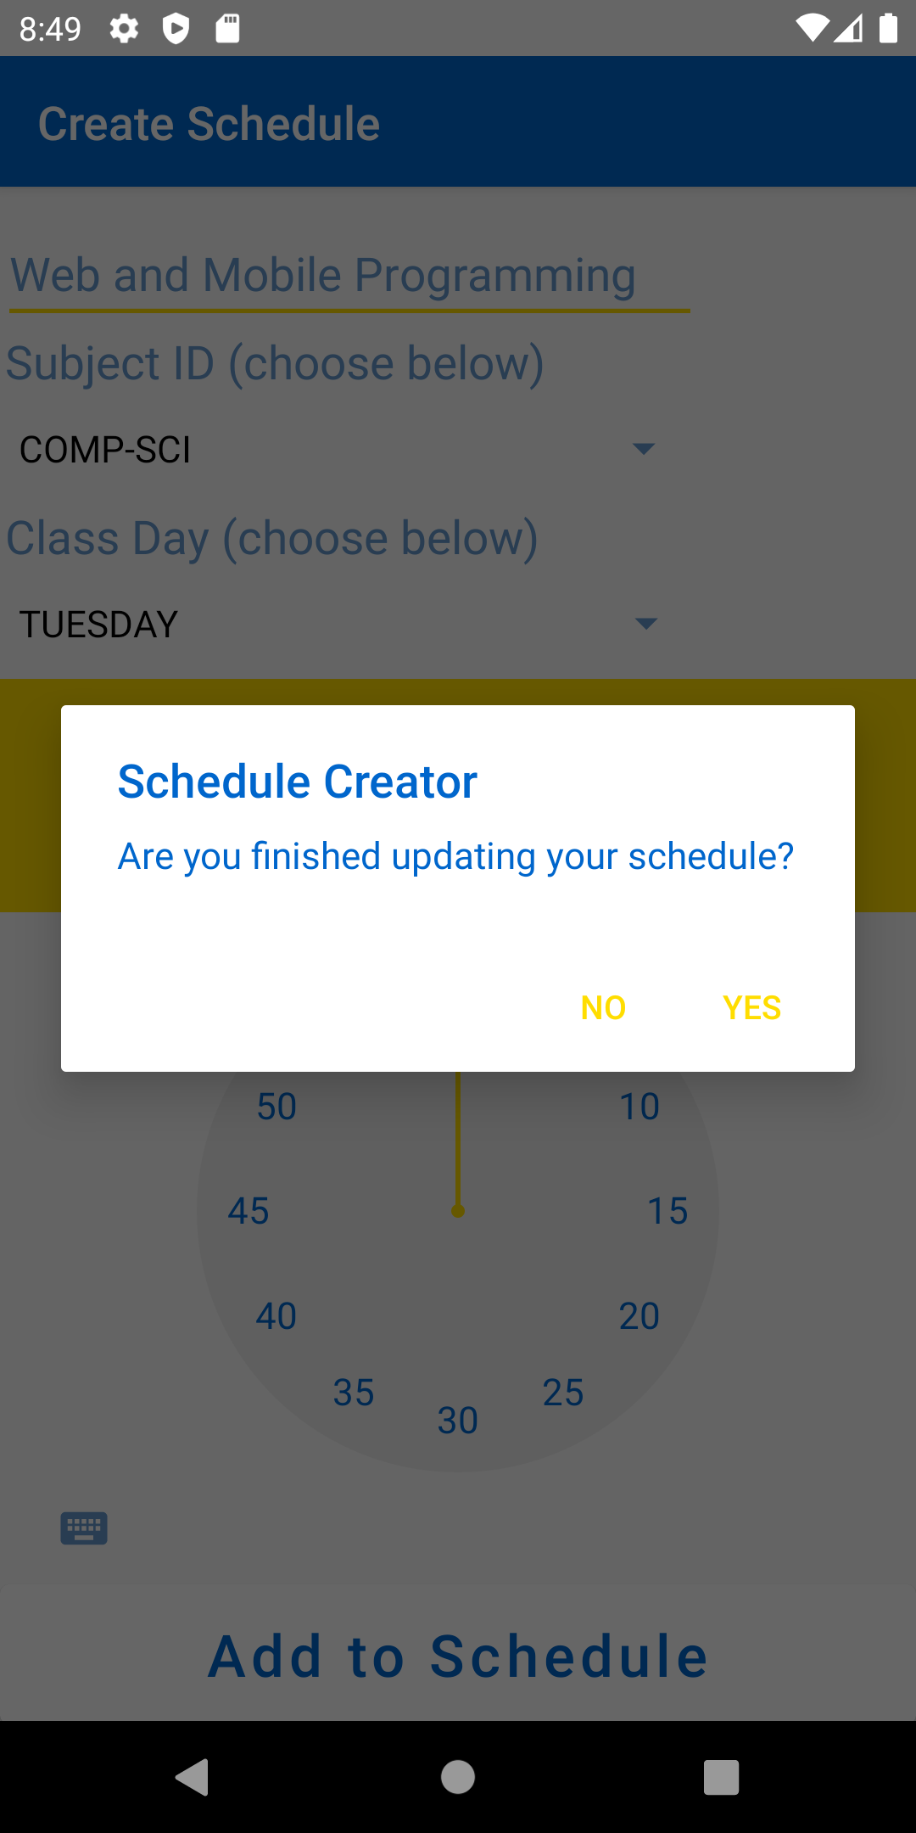

Sign Up:

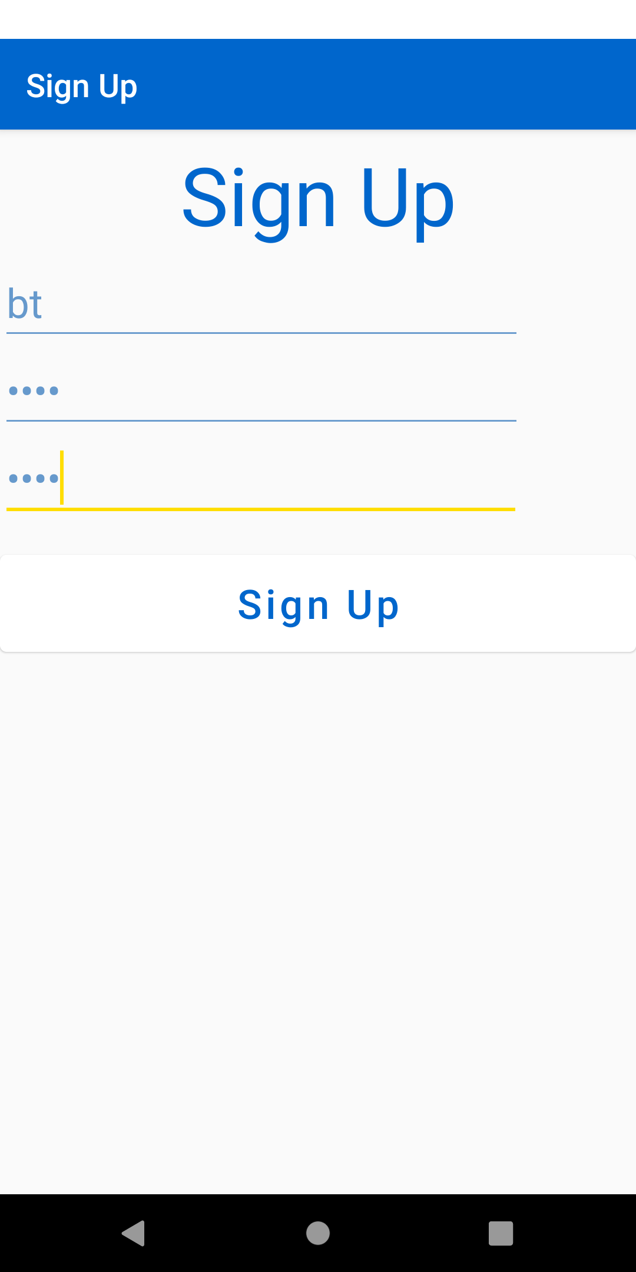

Update Profile:

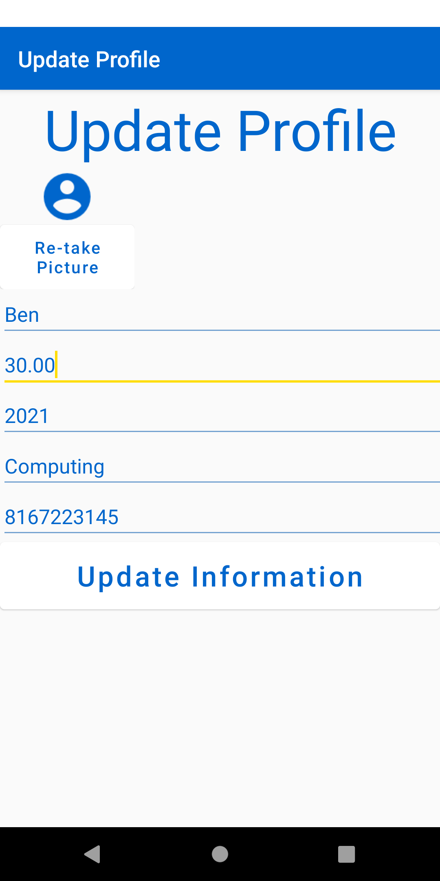

Web Browser:



1. **Contribution:**

Hari Yadav: Base code writeup, weather API, News API support, GitHub host

Ashish Sharma:

Sreevalli Tata: News API, Report

Ben Teig: Main UI/UX Design, Database Work, Presentation Design.

1. **Challenges:**

One issue we had was with gathering data from the database to display within the UI. We had to effectively understand how to use the returned cursor. This was eventually accomplished by implementing the getString() methods and assigning them to appropriate TextViews.

1. **Conclusion:**

**References:**

GitHub Link – <https://github.com/hbyadav/Mobile_project/wiki/Android-App-for-mobile-device----Student-Hub>

Video Link -

Android developers - <https://developer.android.com/index.html>.

Stack Overflow - <http://stackoverflow.com/documentation/android/topics>.